# E-Learning Platform with Auto Evaluation

Title: Day 2 – Design for E-Learning Platform with Auto Evaluation

Date: 13 Sept 2025

Name: Abdul Samad

## Introduction

On Day 1, I gathered the requirements for the E-Learning Platform. The focus of Day 2 is on the design phase. I have created diagrams to represent the system's structure, the flow of data, and how different components interact.

The following diagrams are included:

* System Architecture Diagram
* Use Case Diagram
* Class Diagram

## System Design

System architecture with MySQL and DynamoDB integration, Use Case and Class diagrams included...

### System Architecture Diagram

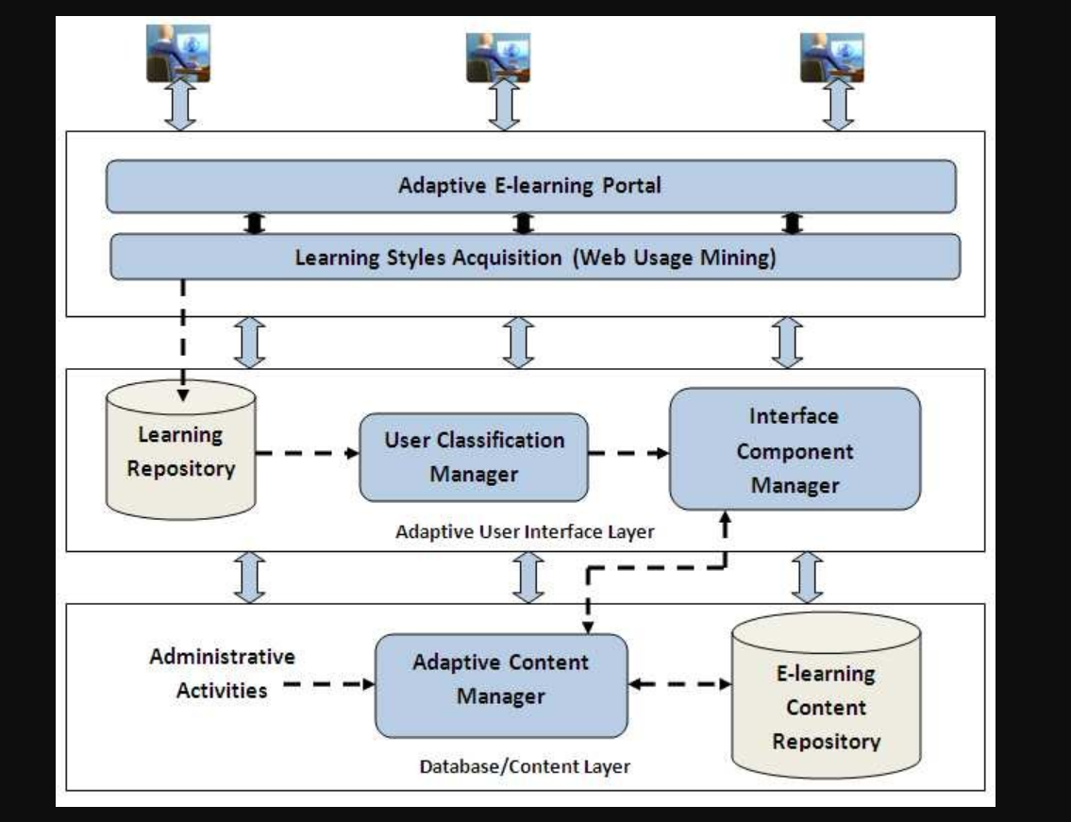

**Diagram Explanation:**

* The **Student** interacts with the system using a Java console-based client application (TUI).
* The **Application Server** handles all business logic, including user authentication, course management, and assignment handling.
* The **MySQL Server** is used to store all metadata, such as student information, course details, assignment descriptions, and grades.
* The **Auto Evaluation Engine** is a separate component that automatically compiles and runs student-submitted code, comparing the output to expected results to generate a grade.

### Use Case Diagram

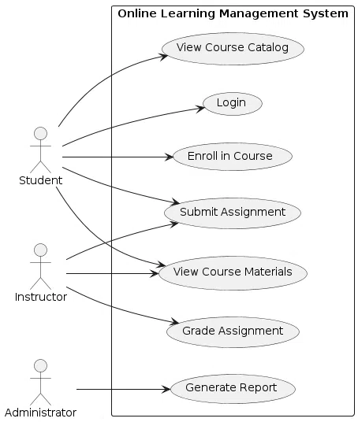

**Diagram Explanation:**

* **Actor:** Student.
* **Use Cases:** Register, Login, Enroll in Course, Submit Assignment, View Grades, Exit.
* Each use case corresponds to a specific menu option in the TUI and maps directly to the functional requirements.

### Class Diagram

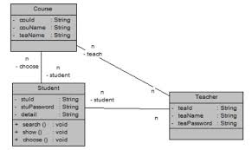

**Diagram Explanation:**

* The **Student** class manages user registration and login.
* The **Course** class represents courses and their details.
* The **Assignment** class holds information about each assignment, including the due date and problem description.
* The **Submission** class links a student to a specific assignment and stores the submitted code.
* The **Grade** class stores the score and feedback for a submission.
* **Multiplicity:**
  + A student can be associated with many courses and submissions.
  + A course can have many students and assignments.
  + An assignment can have multiple submissions from different students.
  + A submission results in one grade.

### Conclusion

On Day 2, I completed the design phase by preparing architecture, use case, and class diagrams for the E-Learning Platform with Auto Evaluation. These diagrams clearly show how the system's components (students, application, databases, and evaluation engine) will interact. This design will guide the coding phase, which begins on Day 3.